Visual Guide

The following visual guide is to aid you on how to play the Crazy Eights game we have created:

# Choosing Your Opponents

As the picture shows above, the user, that’s you, will determine how many human and CPU participants are going to join the game before the commencement of the actual game. This will be done by simply entering the number of human players, followed by the number of computer players. Note that you are only limited to 5 players in total.

# Playing The Game

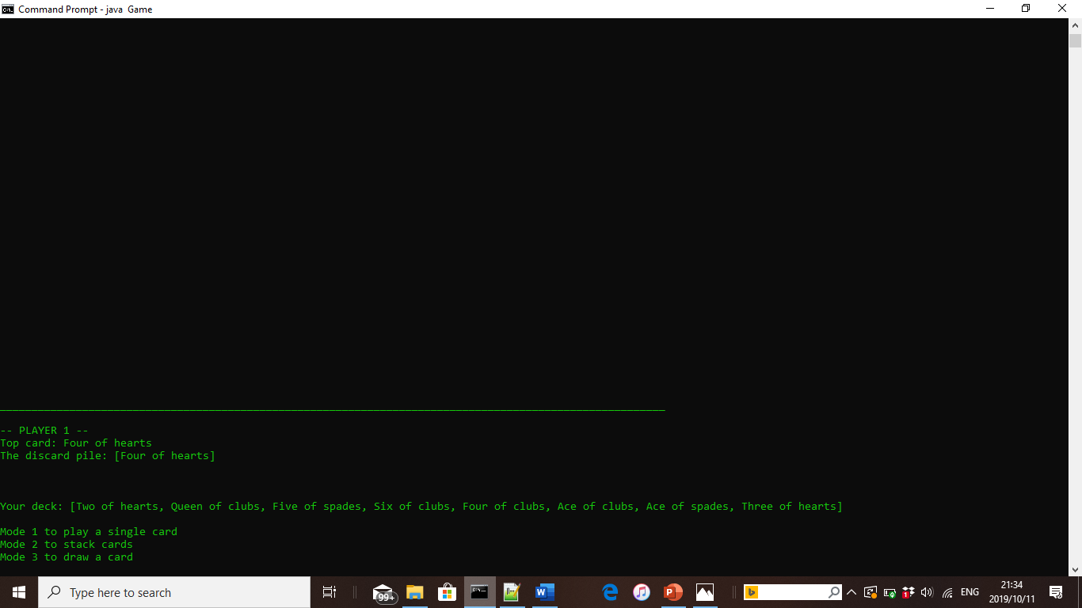

If you are playing alone, you will be Player One and then the computer players will play after you. If you have more than more than one human player the next human plays until all human players have played. Once this happens, the CPU player, if it has been included, plays next and the loop continues.

In the picture above, it is the user’s turn. The user is allowed three choices; they can play a single card, play multiple cards (known as stacking) or they draw a card from the stock. When it comes to stacking, the user can stack numbers that are the same it can stack power cards as well. However, when playing in a two player game ( you vs someone else), it cannot stack the seven power card whose function is to skip the next player.

As you can see in the image above, after your play, the CPU users play after you and they go about their own strategy. The CPU player is allowed to perform most the same functions as the user except the ability to stack kings because we found that it to be too large of an advantage for the CPU player. You would not survive.

# Victory or Defeat. Rematch?

When the dust settles, and the game has a victor, their ID (in this case player number), is boldly posted for all to see who the victor is. After, the option to play again or quit the game is presented to the user. Should the user wish to play again, all they have to do is press any key before pressing enter. However to adjust the number of players, you will have to quit and start again.